May 10, 2021
Dear [Mr./Mrs. Member of Parliament],
I write to you today [as a local business owner / constituent in your riding] to express my grave concern about the ‘luxury tax’ on new boats over $250,000 announced in the recent federal budget. This new tax unfairly targets workers in the recreational boating industry and will lead to a severe drop in sales revenue and increased job losses across the country.
I understand that the government is running a record deficit to support Canadians through the COVID-19 pandemic and needs to find new revenue sources. However, as one business owner in our industry recently said on the luxury tax: “you’re hurting the people you are trying to help”. The history of past luxury taxes has shown that many consumers will simply refuse to purchase the taxed item. In this scenario, the customer who chooses not to buy a luxury taxed boat is not any worse off — it is middle-class business owners and workers who will bear the brunt of this policy when their jobs are lost due to lower demand.
The economic damage of the luxury tax would be swift and severe. A recent survey of 325 Canadian recreational boating businesses conducted in partnership by all of Canada’s Marine Trade Associations found:
- Affected businesses predict an average 56% drop in sales after the tax comes into effect, meaning about $178 million in lost annual revenue;
  - “97% of our boats sold into 2022 are in the $250K + range. Every single one of these customers has called and said they will cancel their order if the tax takes effect.”

- 75 businesses anticipate having to make job cuts;
  - “Likely let go 30% of our staff as we have a service department just for new boat clients.”

- 12 surveyed businesses expect the luxury tax will force them to close permanently.
  - “It will close my business. Period. Devastating effect on business and industry as we know it.”
Each of these boats are HST generating microeconomies. Typically, these boats are sold four times over 20 years plus they create annual economic gains from slip rentals, winterizing, service, storage, fuel, and more.

The following chart outlines potential HST revenue from larger boats in Atlantic Canada.
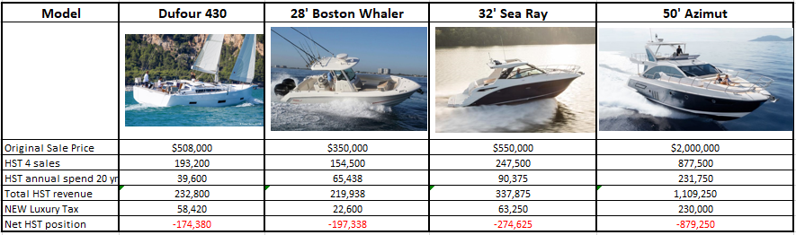

For many middle-class Canadian families for whom the cottage market has become an unreachable goal, many people chose to make boats their family cottage. Recent surveys found that 59% of boat buying families having an average household income of under $100,000, it is essential that we keep an available supply of these boats in the pipeline.
Luxury taxes have backfired many times before. In the early 1990s, the U.S. introduced a similar luxury tax on boats that devastated the industry. One yacht builder went from 220 to 50 employees, another, from 95 to 8. The tax was eventually repealed...but not before destroying thousands of jobs and resulting in a net revenue loss of $8 million to the government. New Zealand, Italy, Norway, Turkey and Spain have previously introduced luxury taxes on boats, all of which were ultimately repealed due to the net-negative economic effects.
I urge you to stand up for recreational boating businesses and workers in your riding and across Canada and oppose the unfair and damaging new luxury tax. On the cusp of a fragile economic recovery, we cannot afford yet another tax that would put good middle-class jobs at risk.
Sincerely,

